**PAF- KARACHI INSTITUTE OF ECONOMICS & TECHNOLOGY**

**College Of Engineering**

(

Department of Software Engineering

)



**PROJECT REPORT OF**

**OBJECT-ORIENTED PROGRAMMING**

|  |  |  |
| --- | --- | --- |
| **GROUP MEMBERS:** | ASAD RASHEED (14230)  HASEEB ALI (12998)  MUHAMMAD UZAIR (13765) |  |
|  |  |  |
| **TEACHER NAME:** | **FAYYAZ KHAN** |  |
| **SECTION:** | **___________** |  |
| **PROJECT TOPIC:** | LIBRARY MANAGEMENT SYSTEM |  |

**OBJECTIVE:**

The main objective of the C# Project on Library Management System is to manage the details of Member, Librarian, Books, Issues, Student. It manages all the information about Member, Address, Student, Member. The project is totally built at administrative end and thus only the administrator is guaranteed the access.

**PROJECT DESCRIPTION:**

Library management system project used to maintain all activities of library system such as maintain books stock, issue book records, return book records, student detail. The project covered all activities which has done to run library system.

The Library Management System in C# is best for any schools or public libraries who want to switch their manual process into automated. This will definitely help the librarians in keeping all the book records safely and it will save them a lot of time and effort.

The Librarian has a username and password to access the system. After login he has to first add publication detail in to system and then enter all the detail of book stock. In our system librarian can make entry of student who are the members of our system. Librarian can register all students with valid personal detail and generate username and password for each student for login into system. Librarian issue books to registered student and get return from them. This project uses Object-Oriented Programming (OOP) concepts. In this project we use inheritance which is one of the main pillars of OOP. In this project abstraction is used, as the windows form or GUI is type of abstraction because the user cannot see backend coding, it only interacts with the GUI interface or windows form application. We also use MS-SQL for database.

**FLOW CHART:**

**PROJECT CODE:**

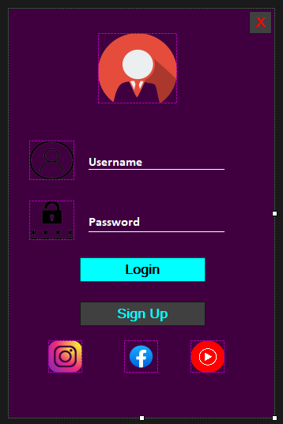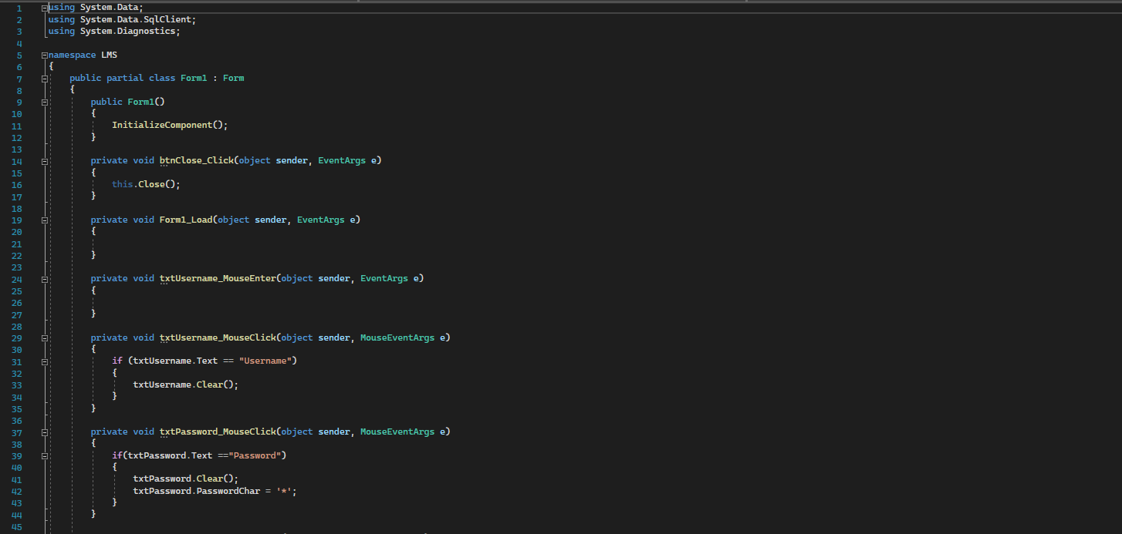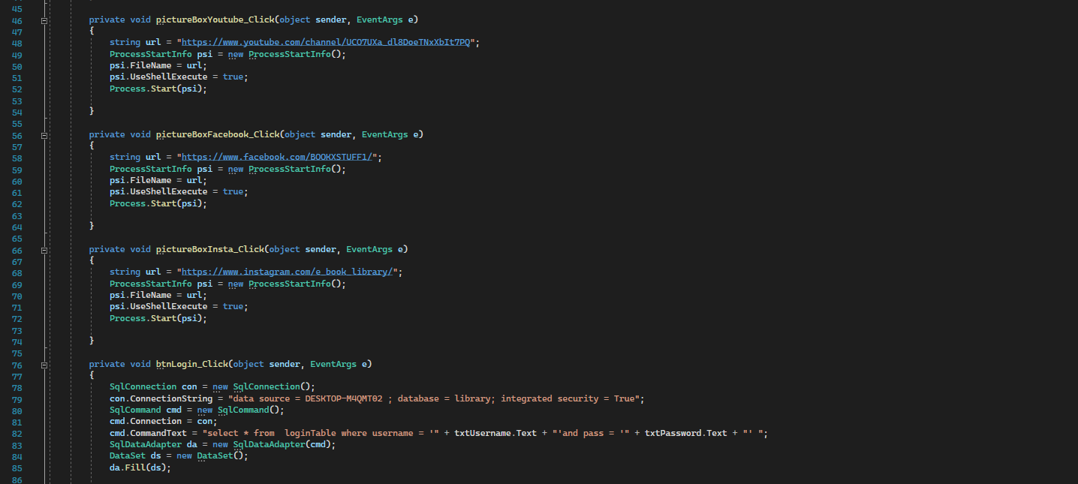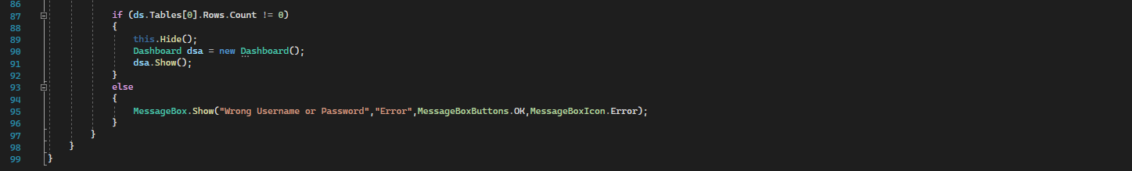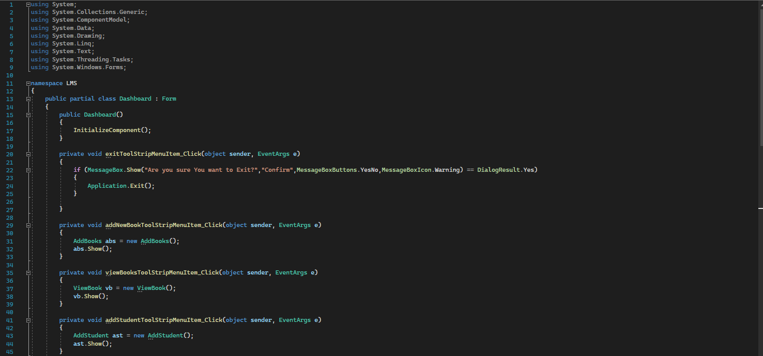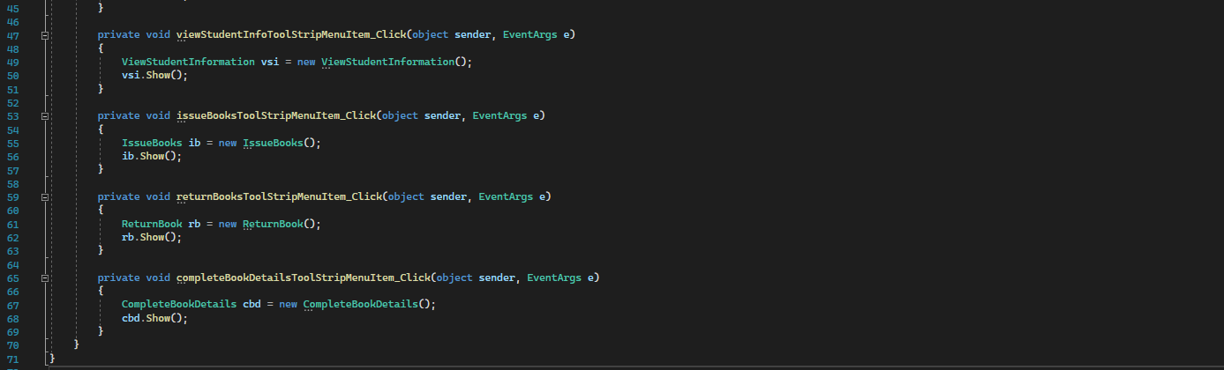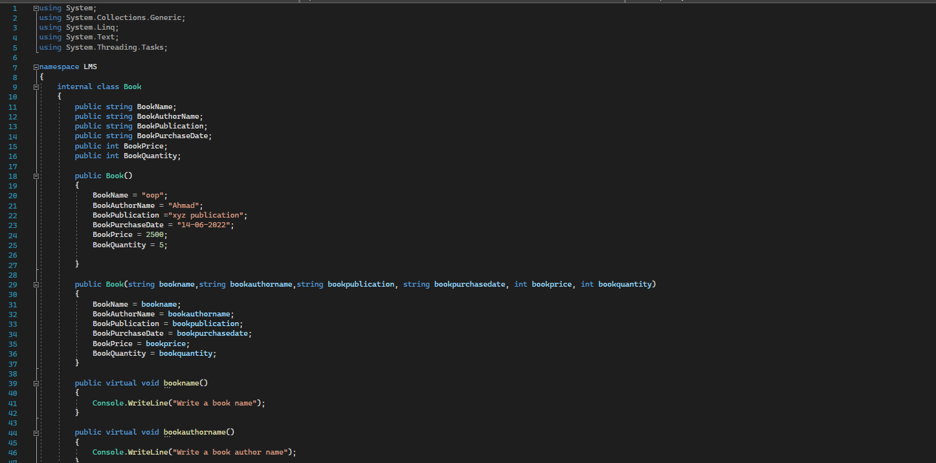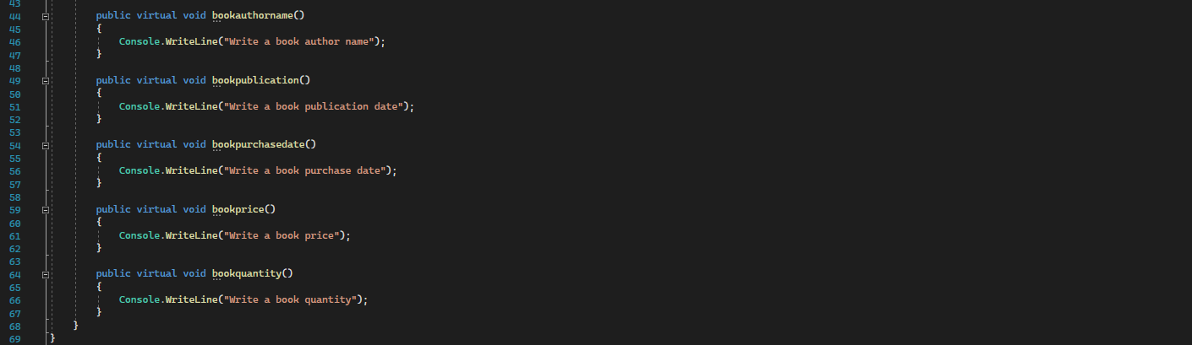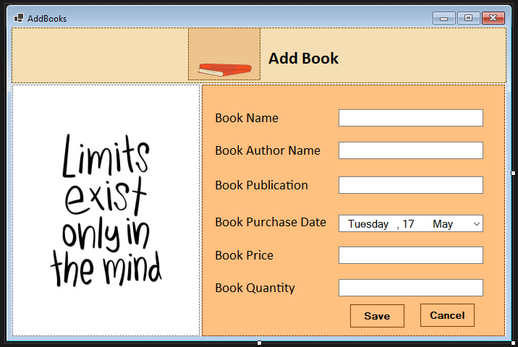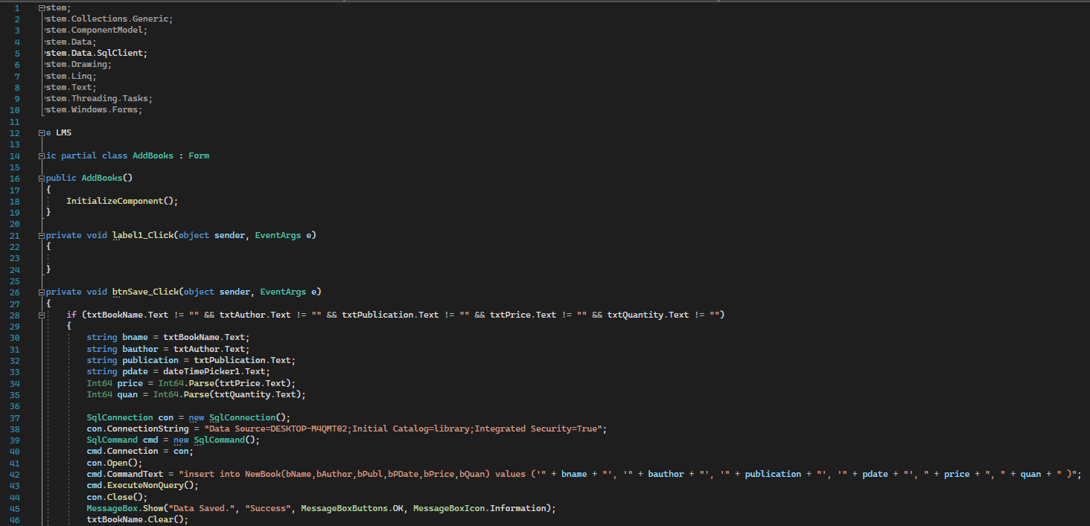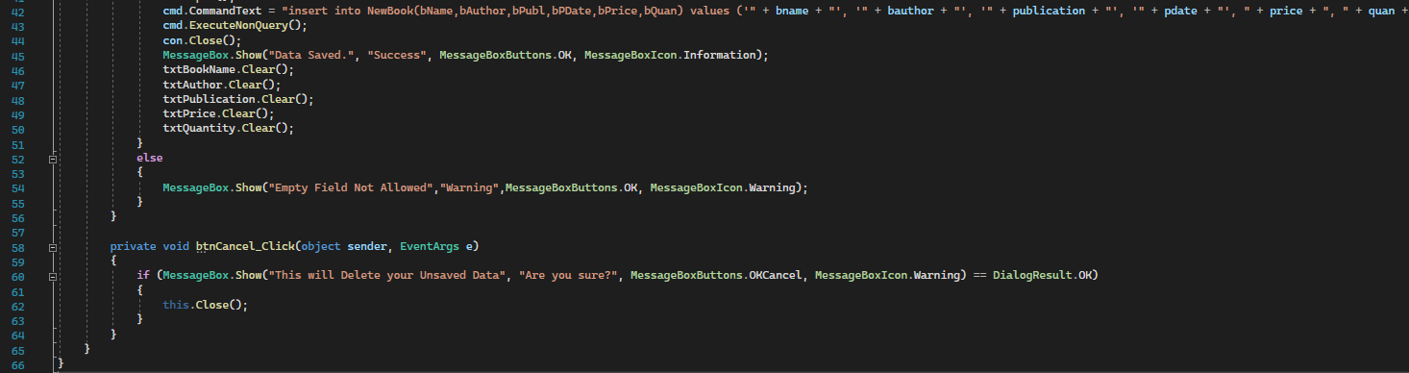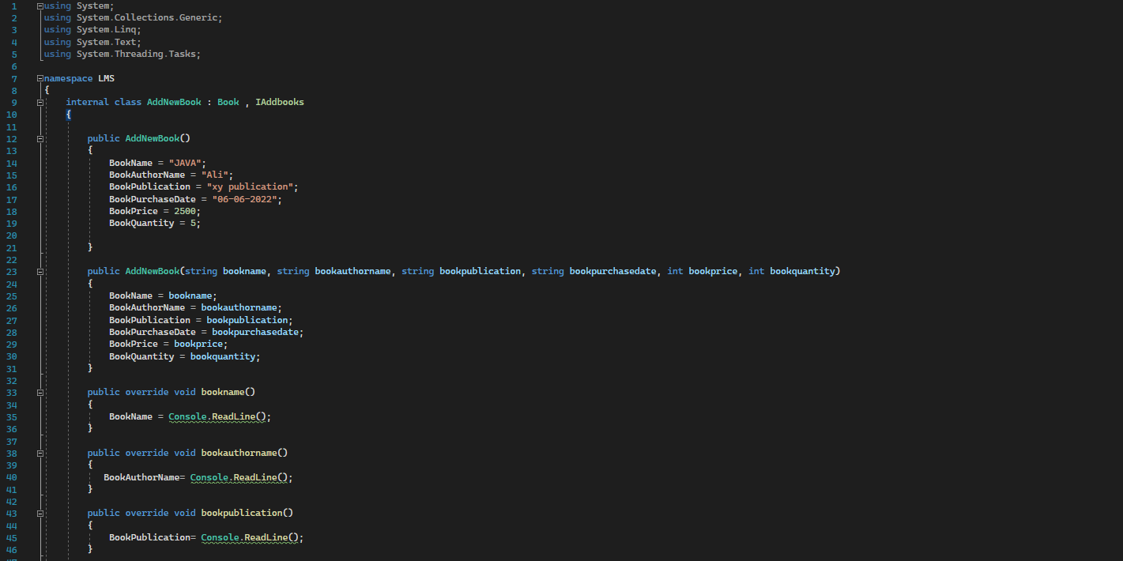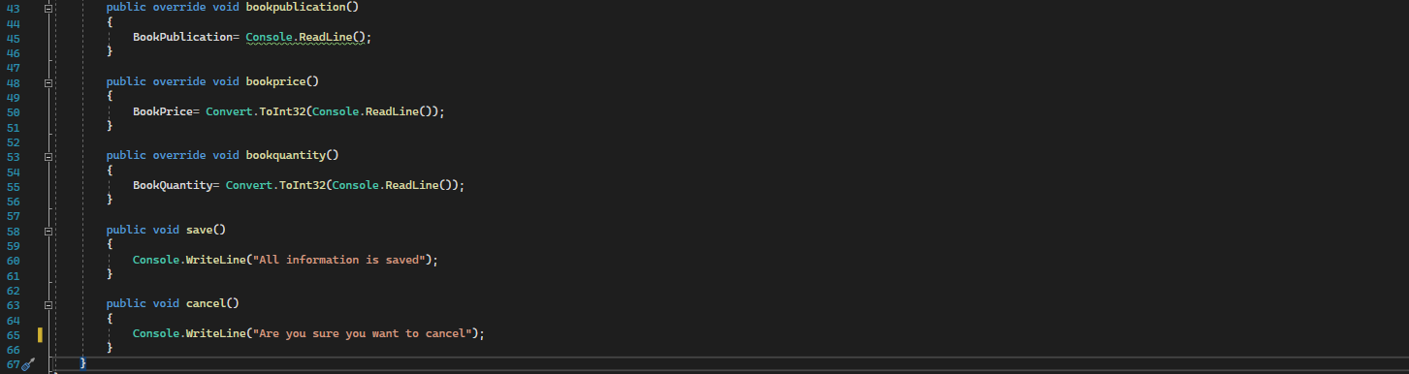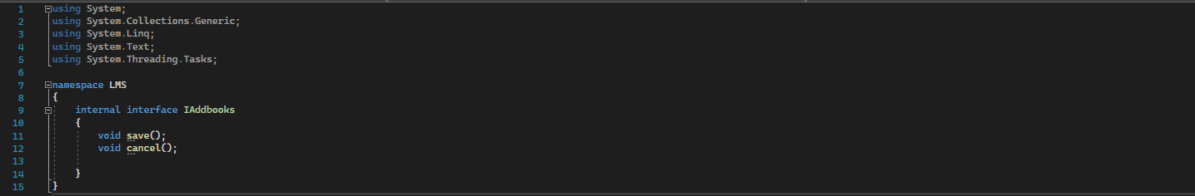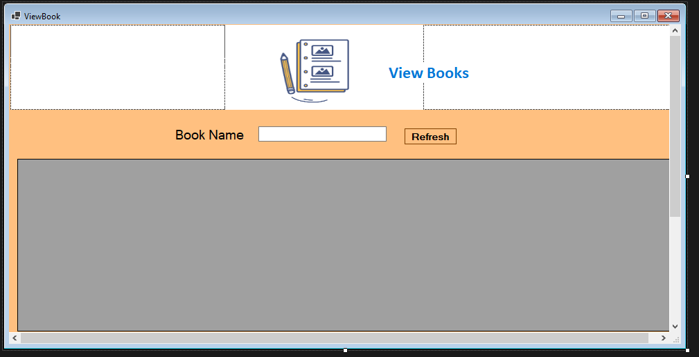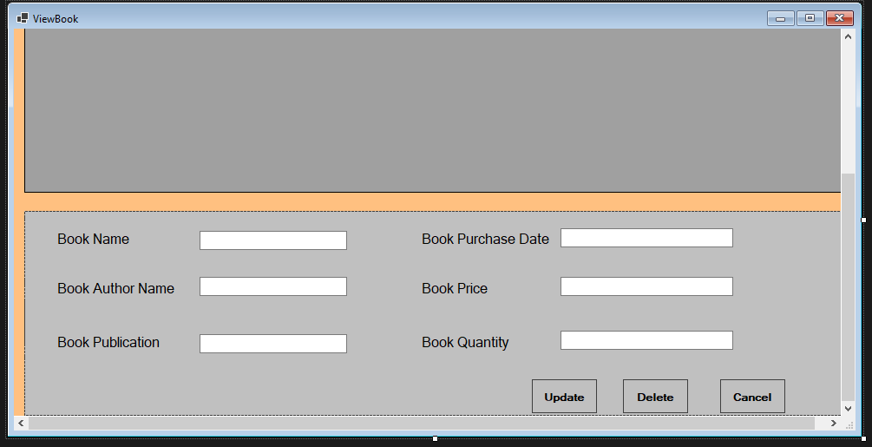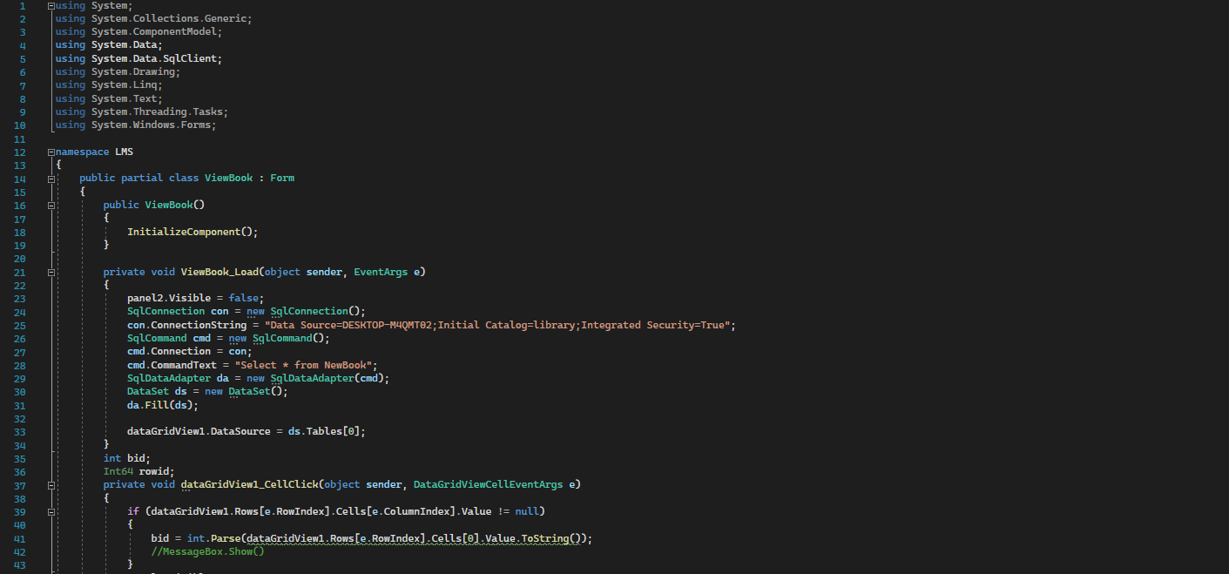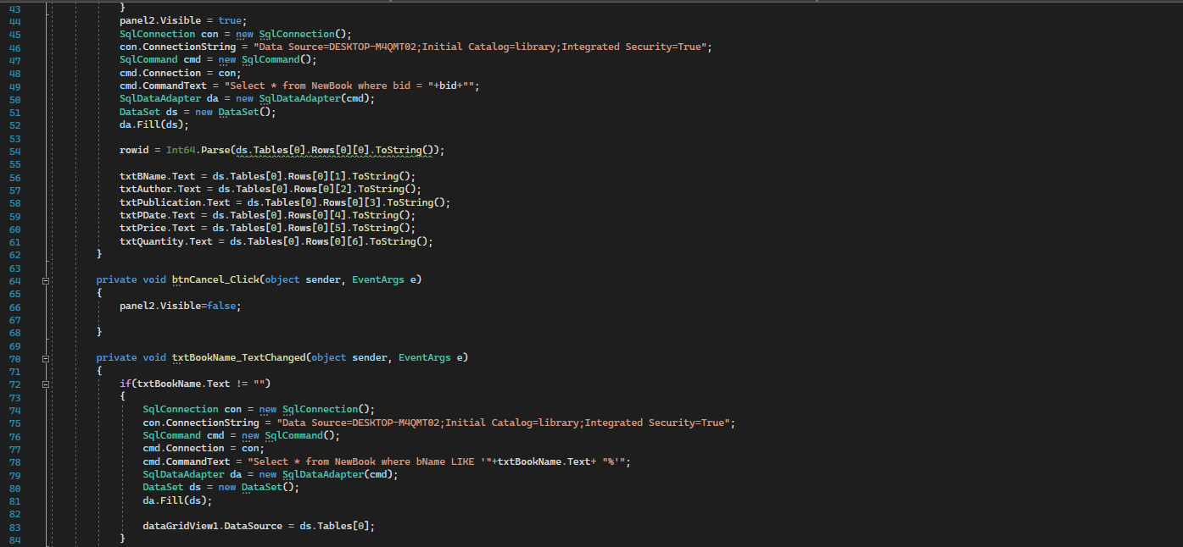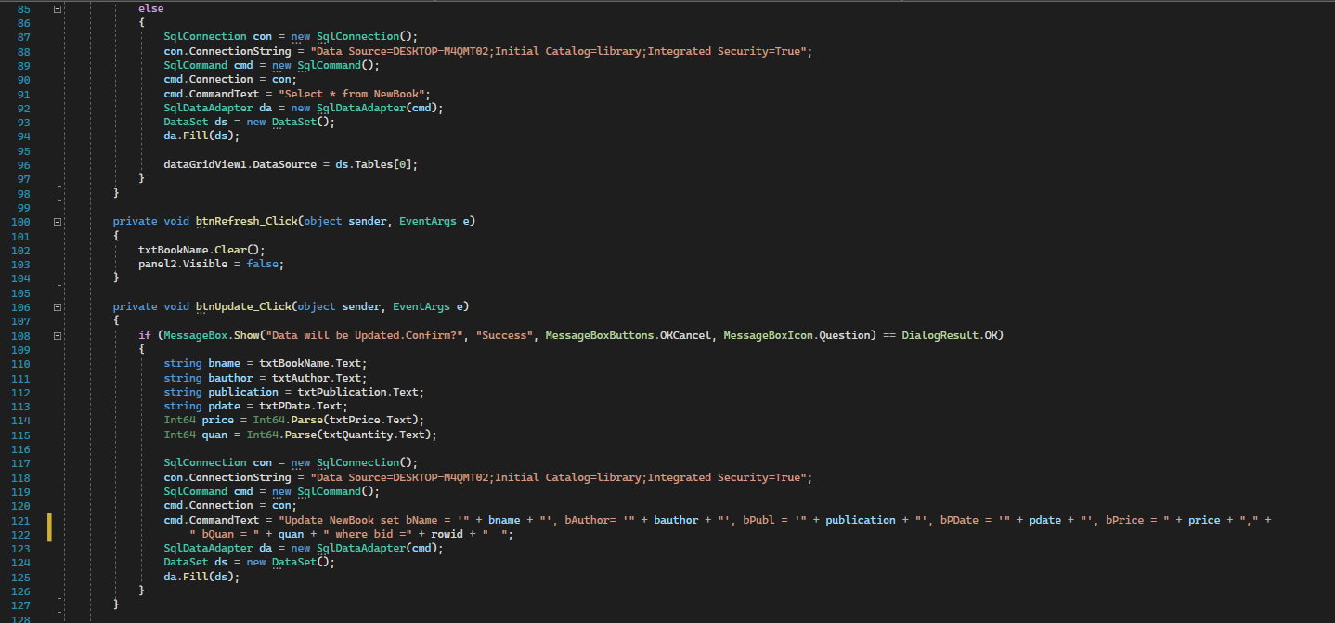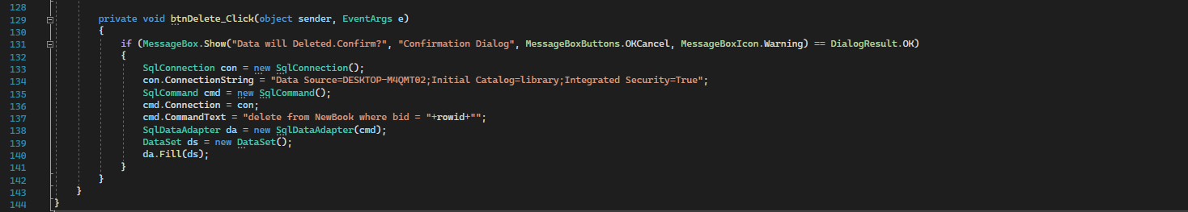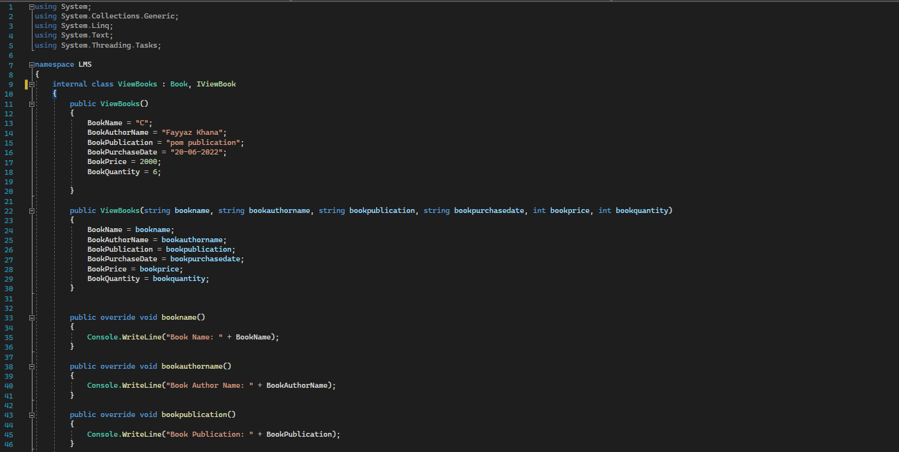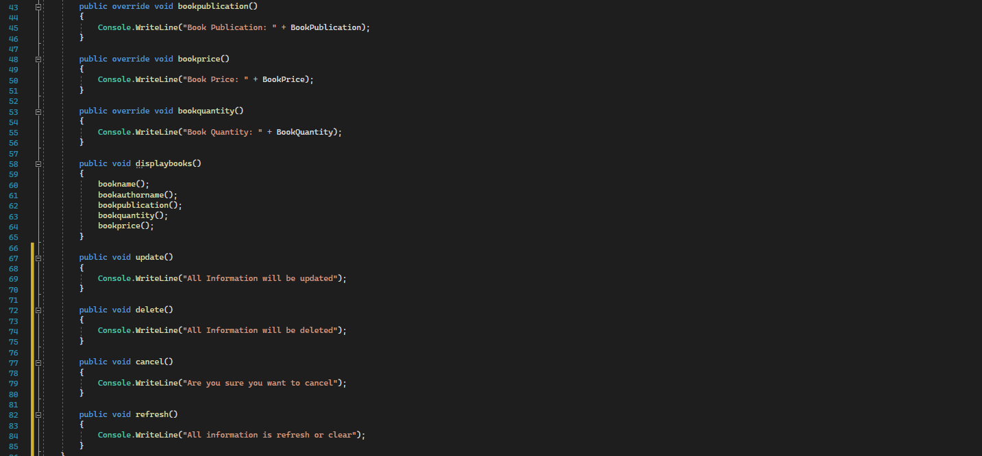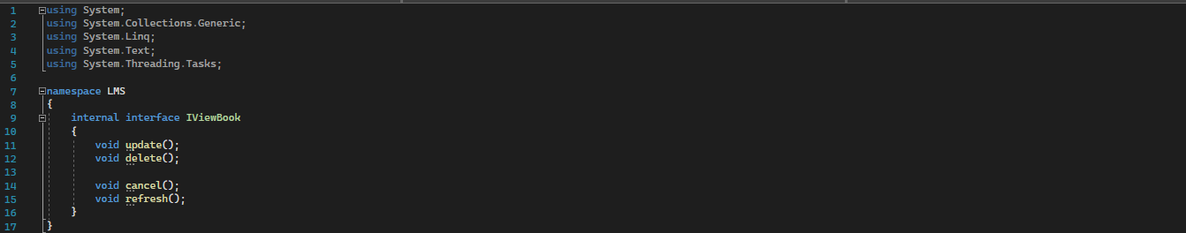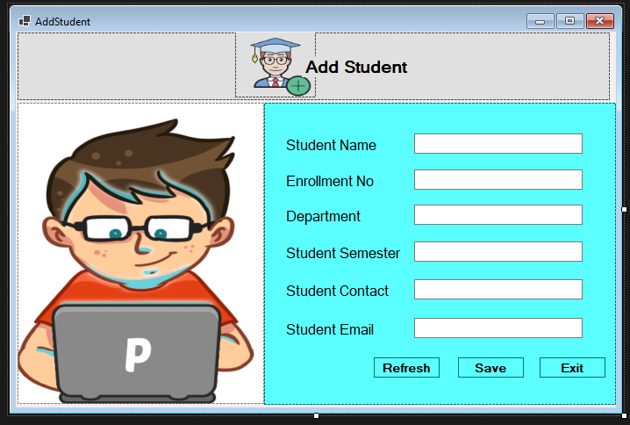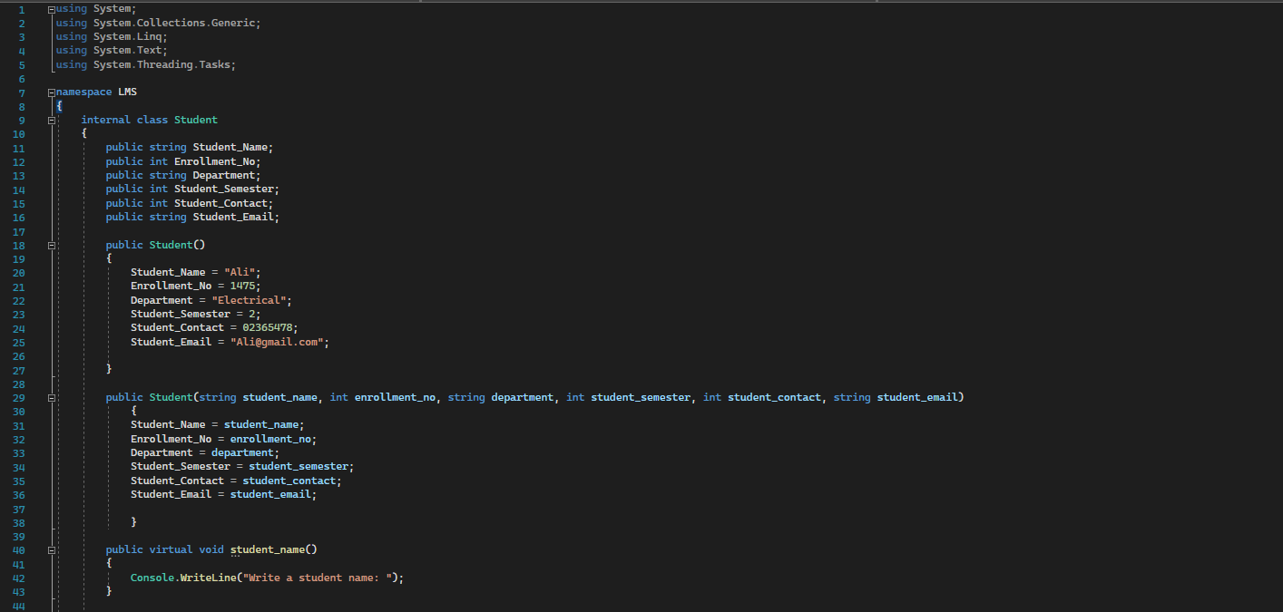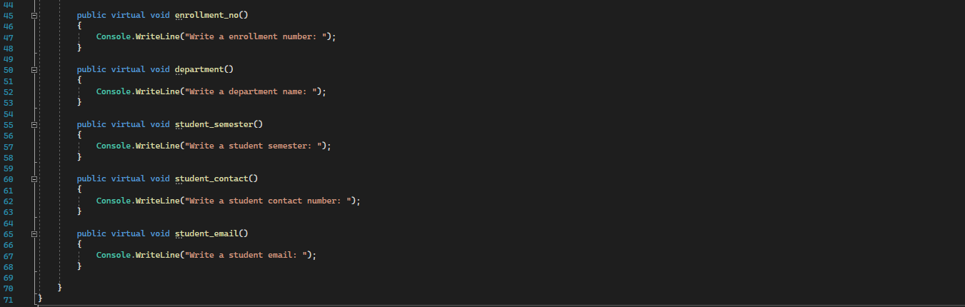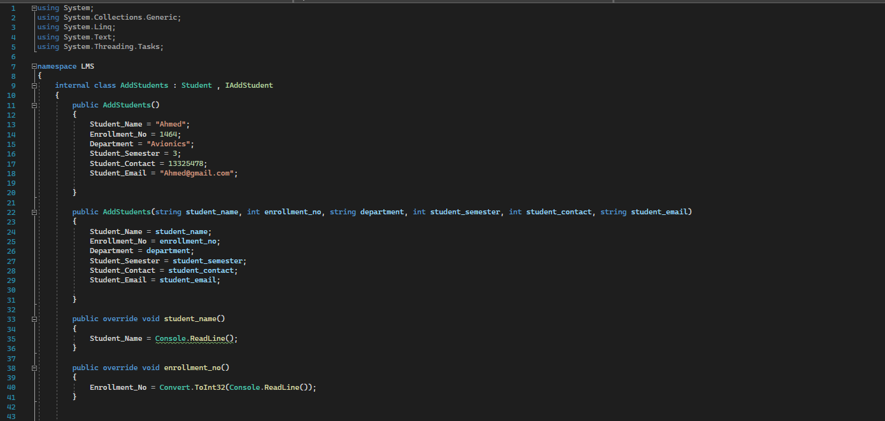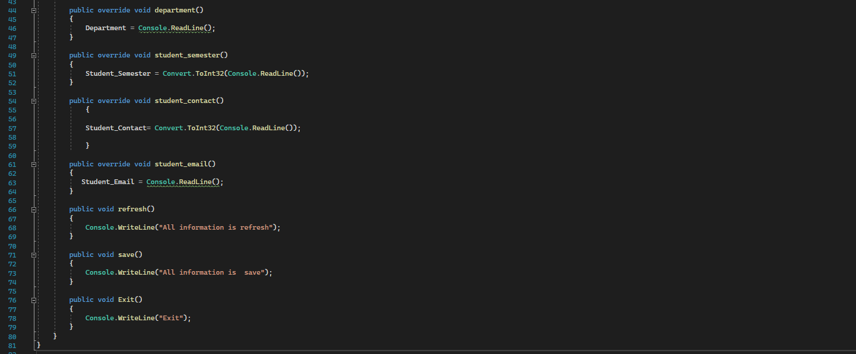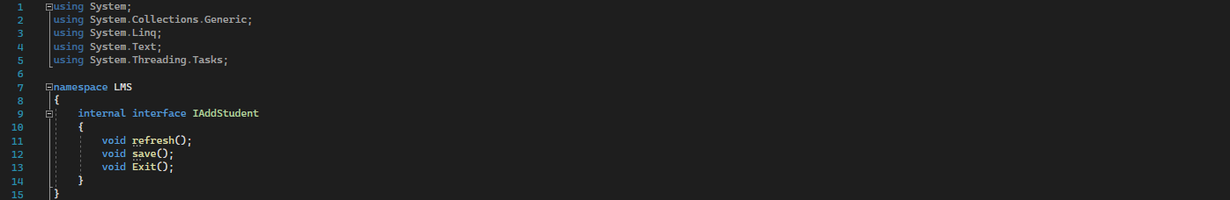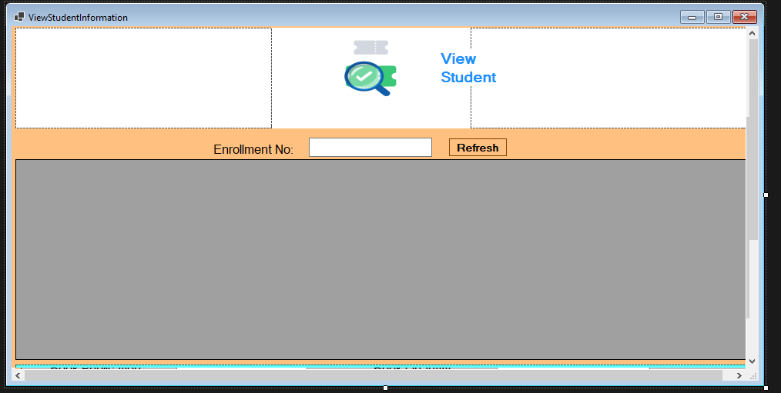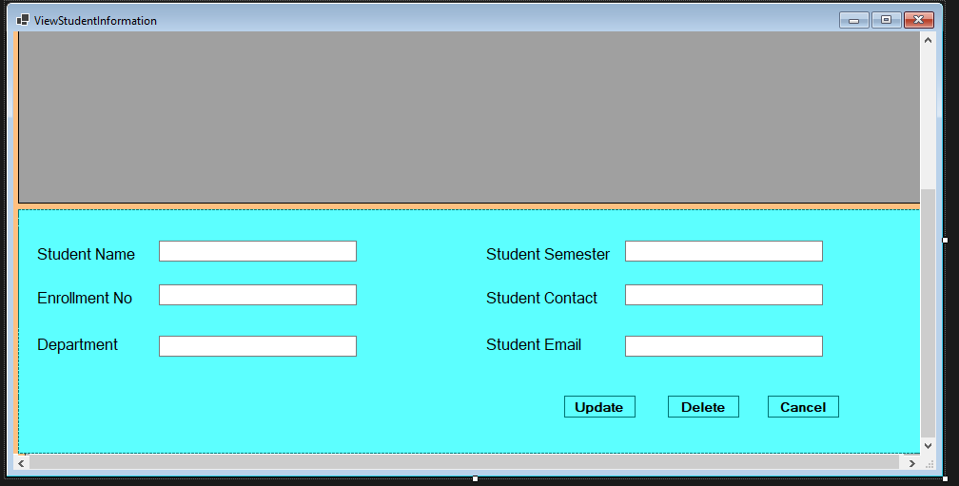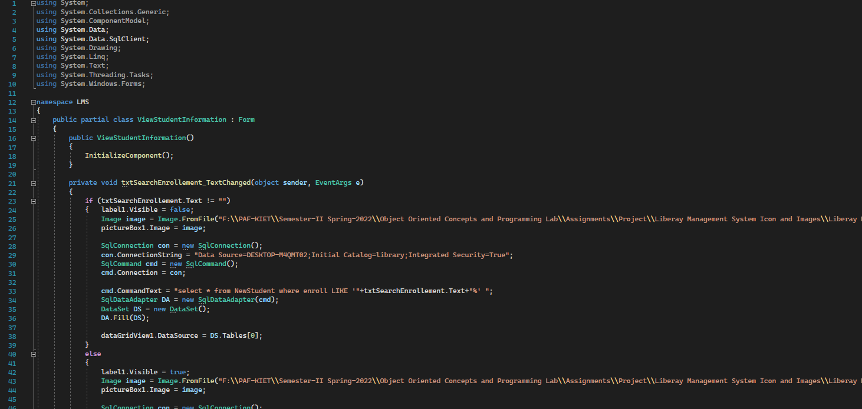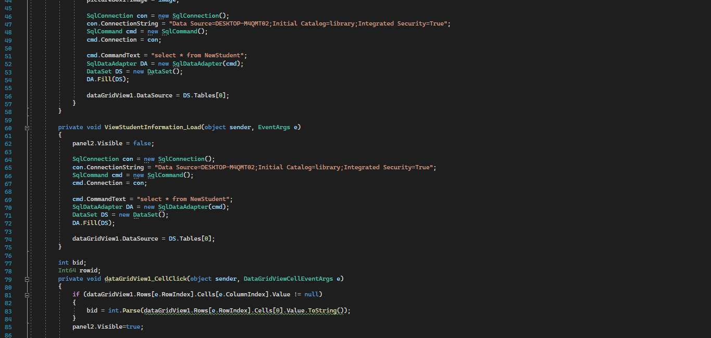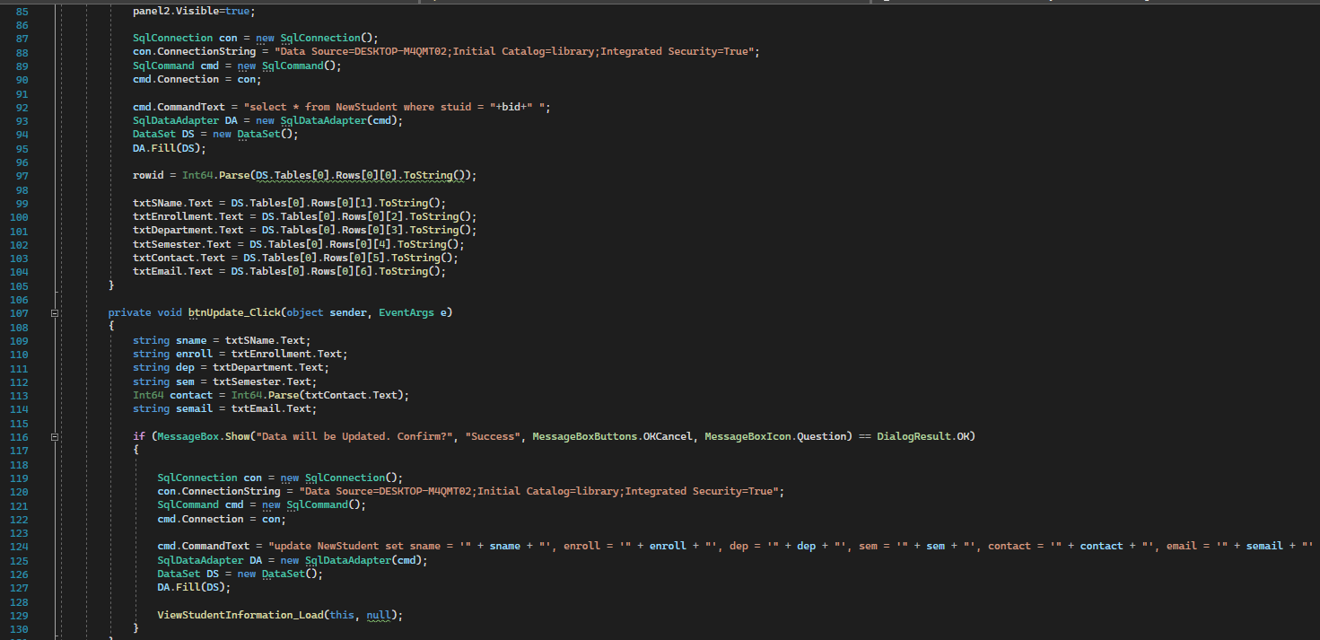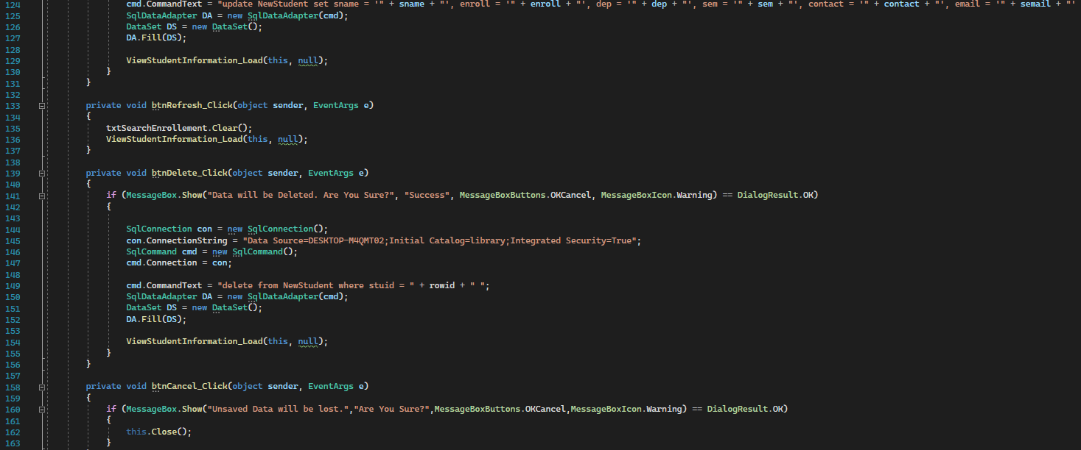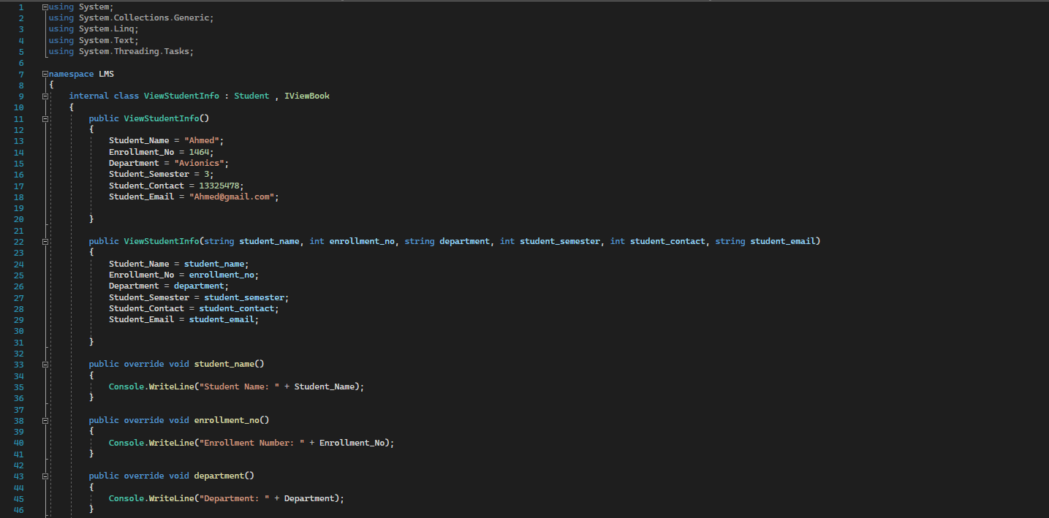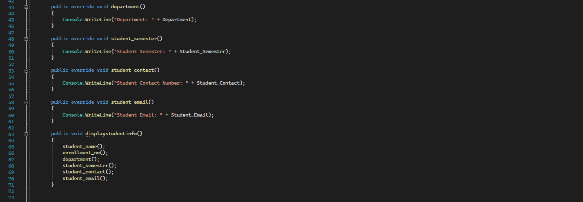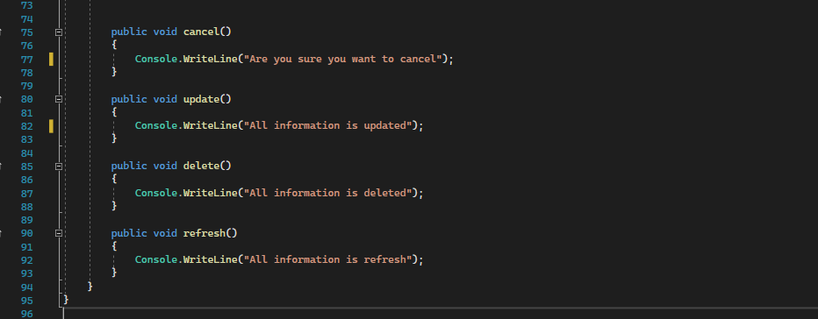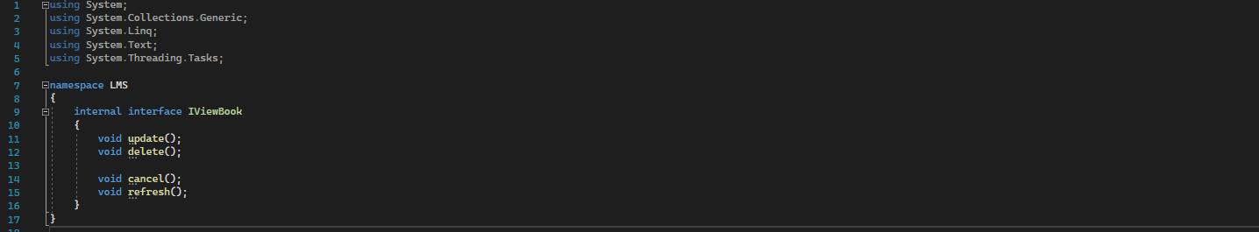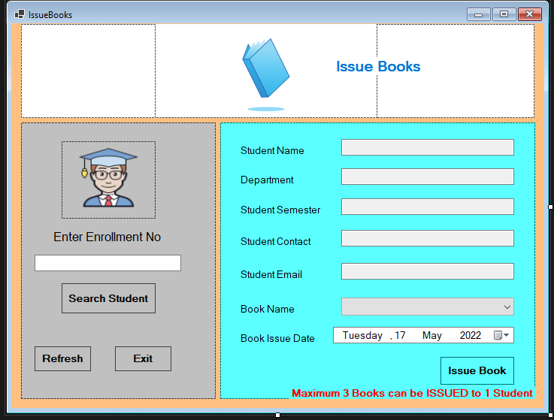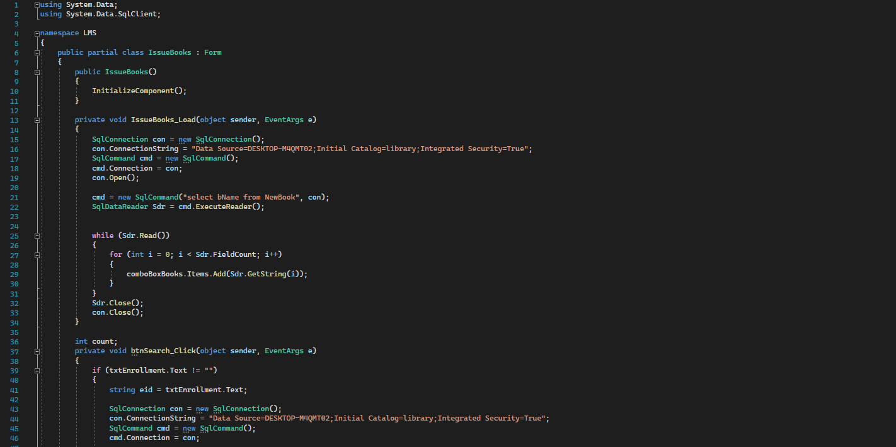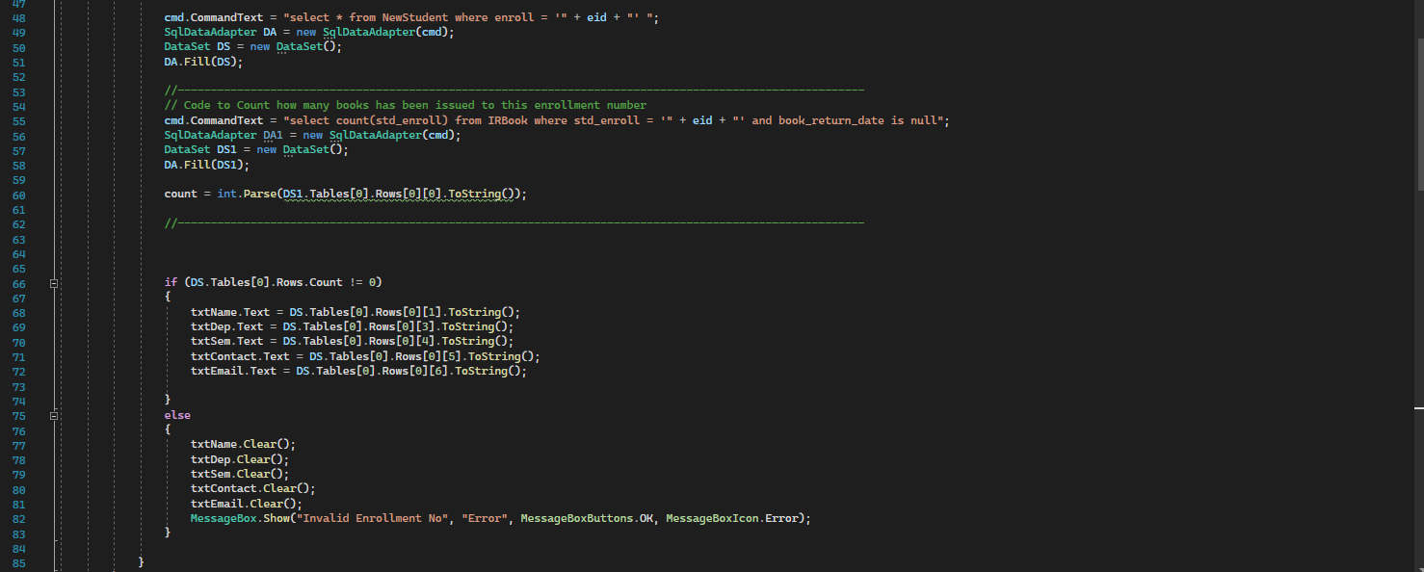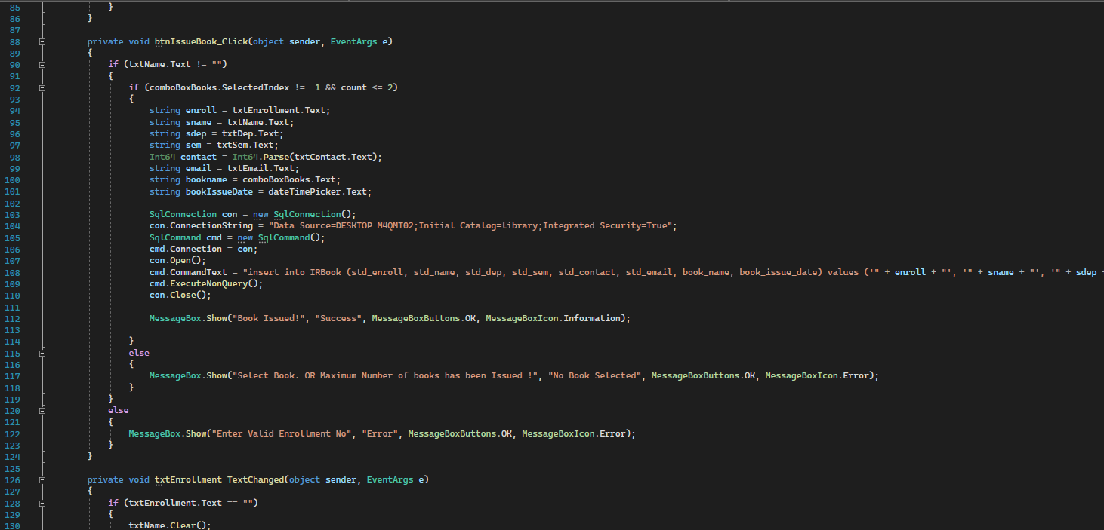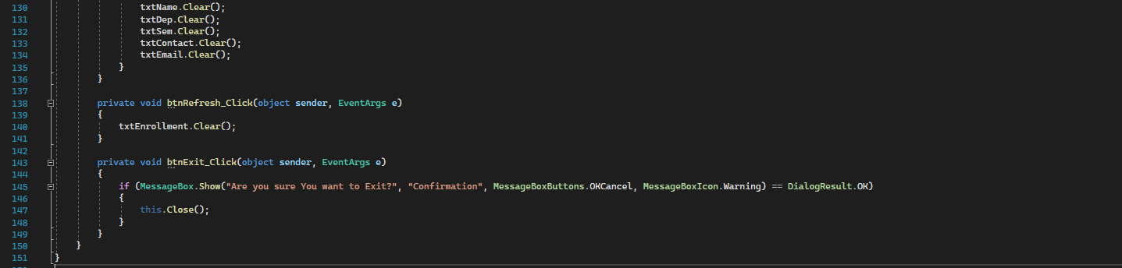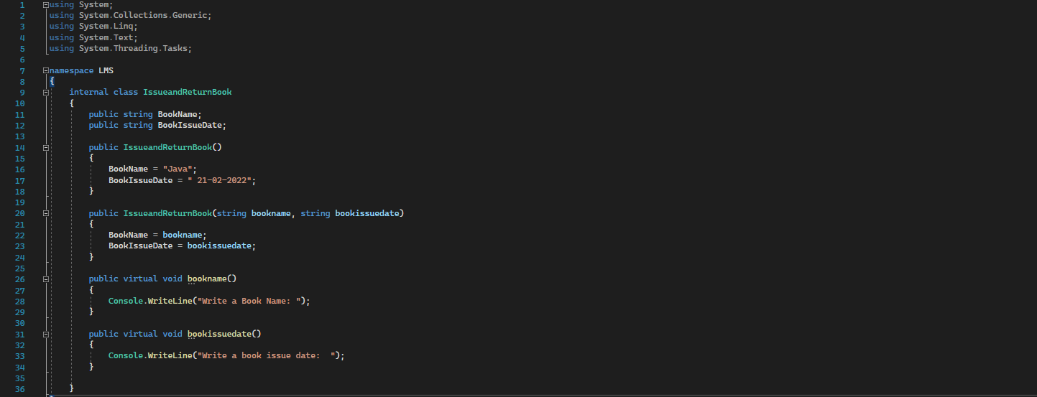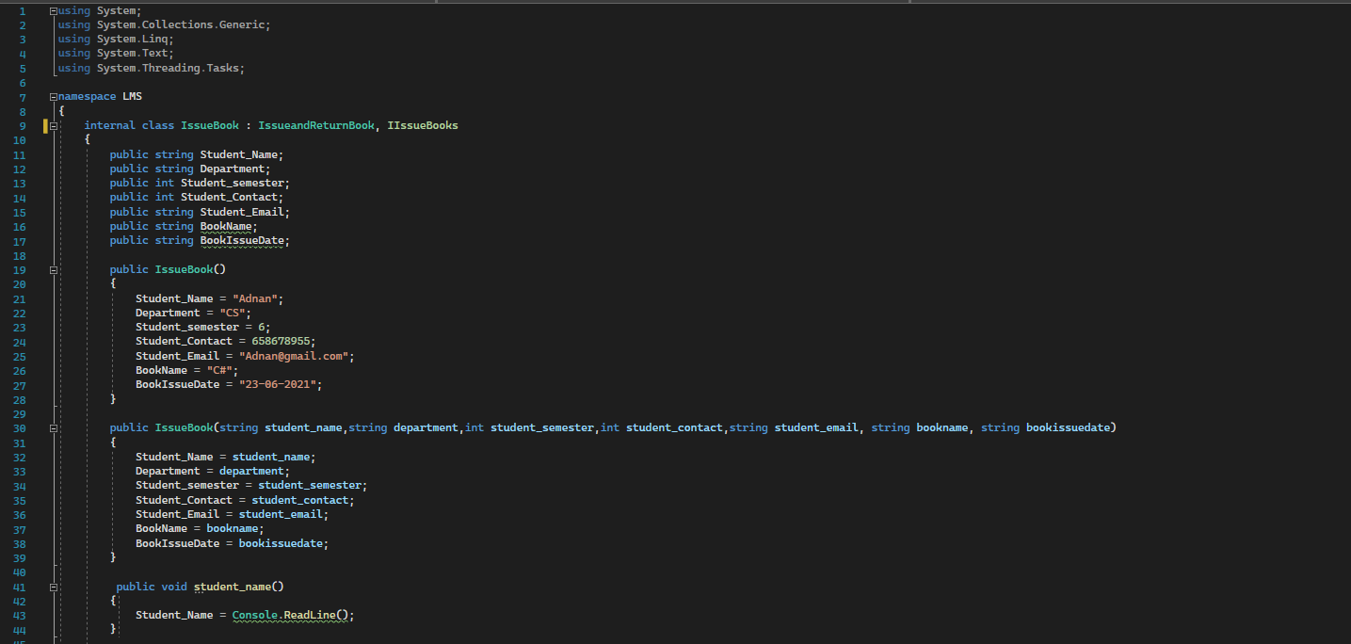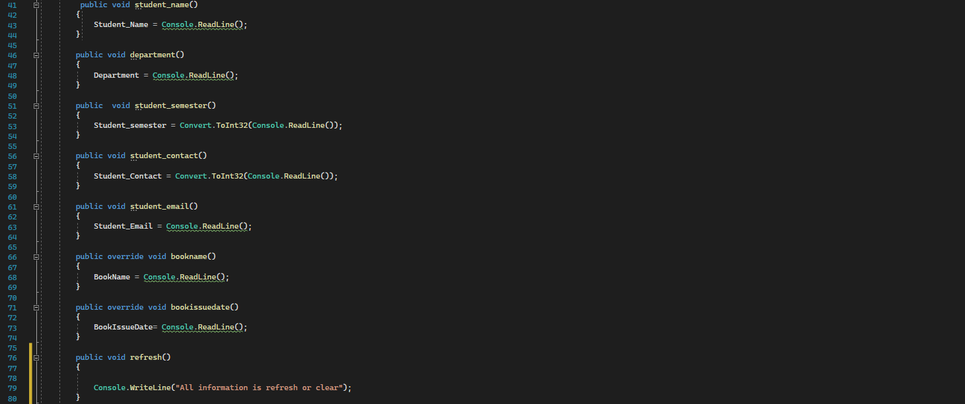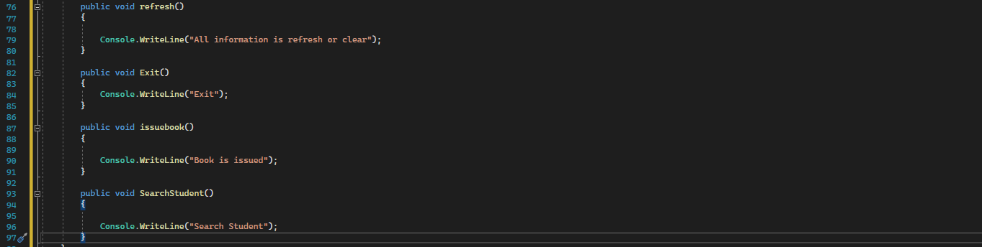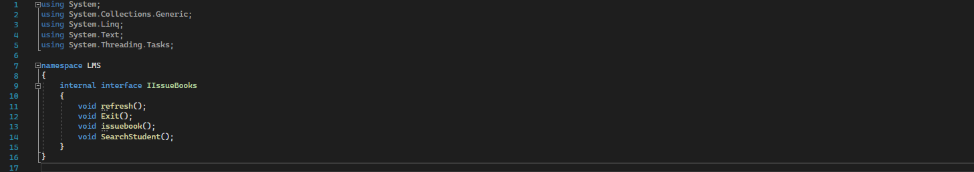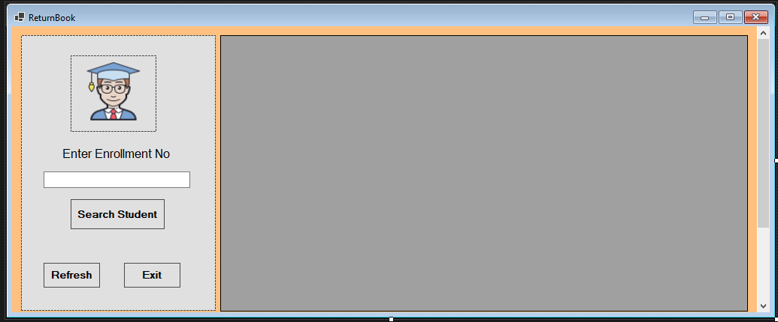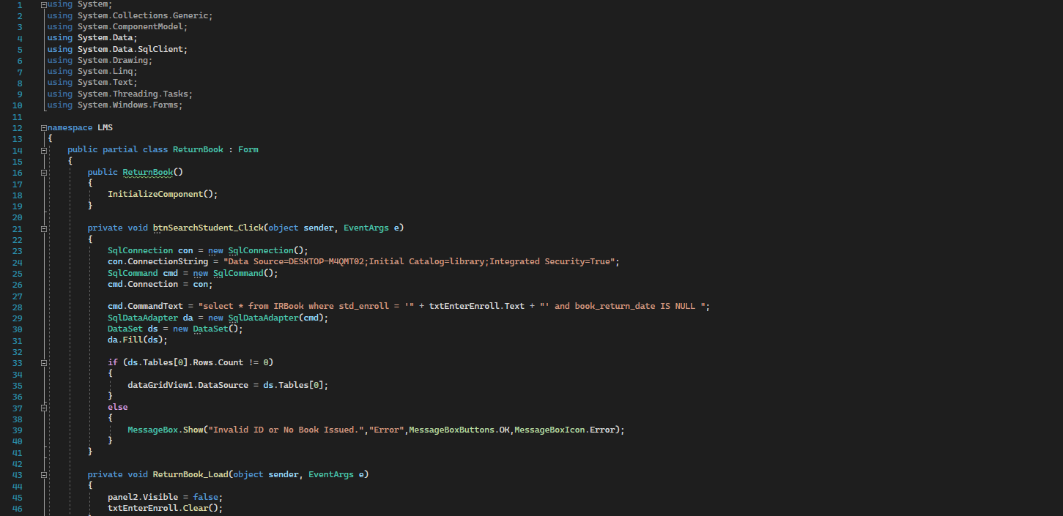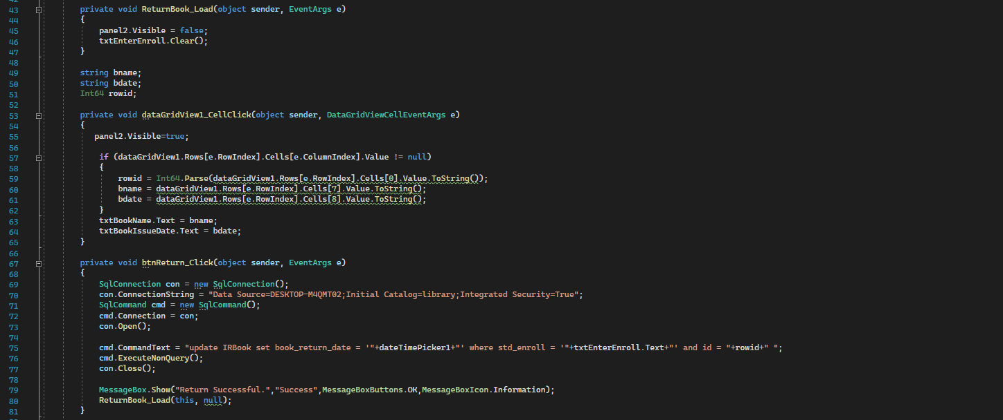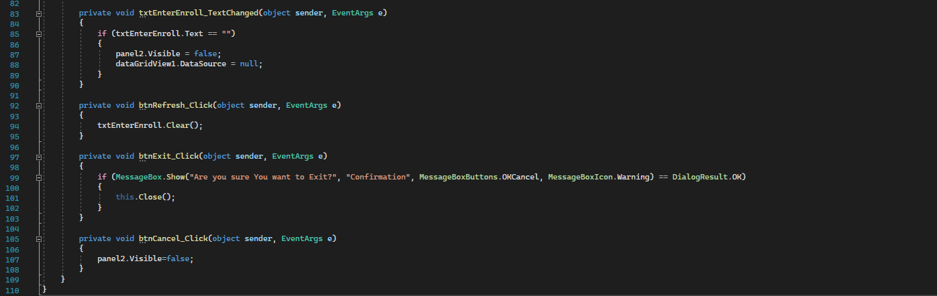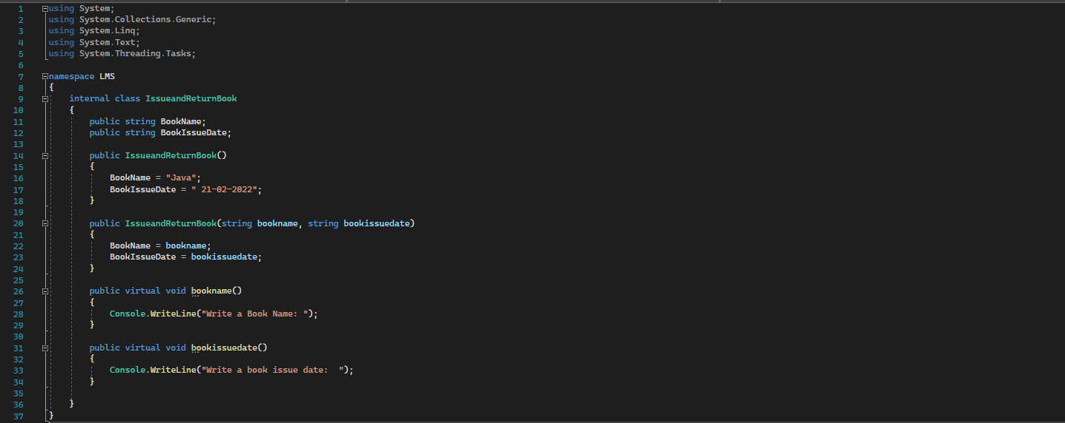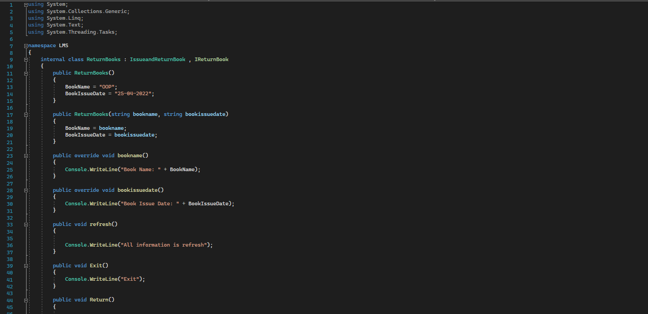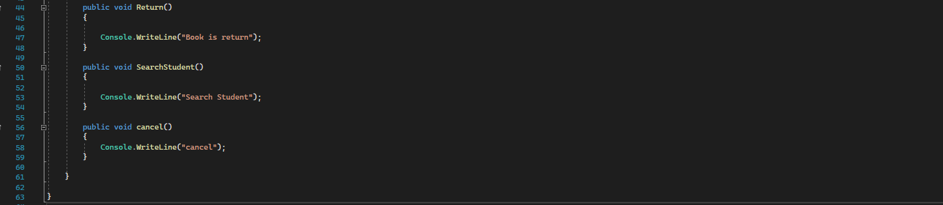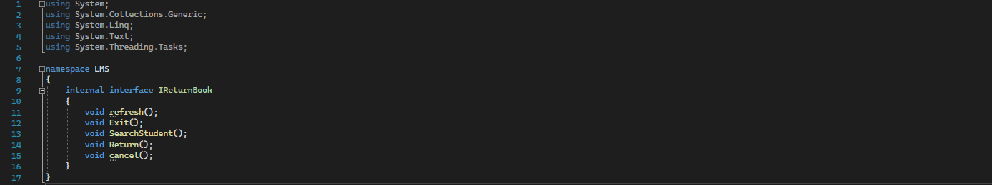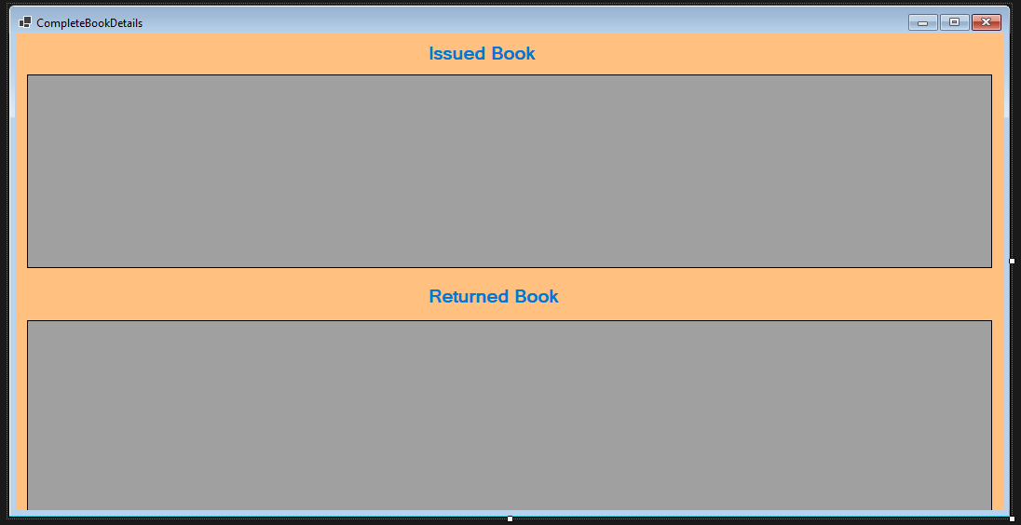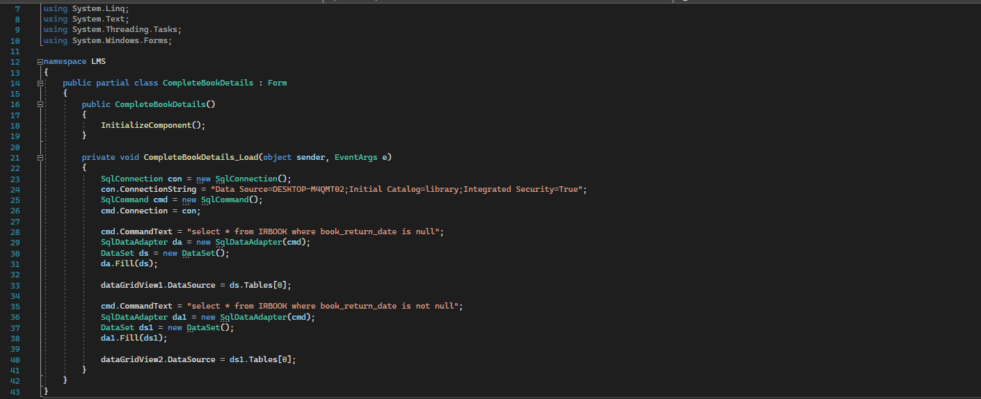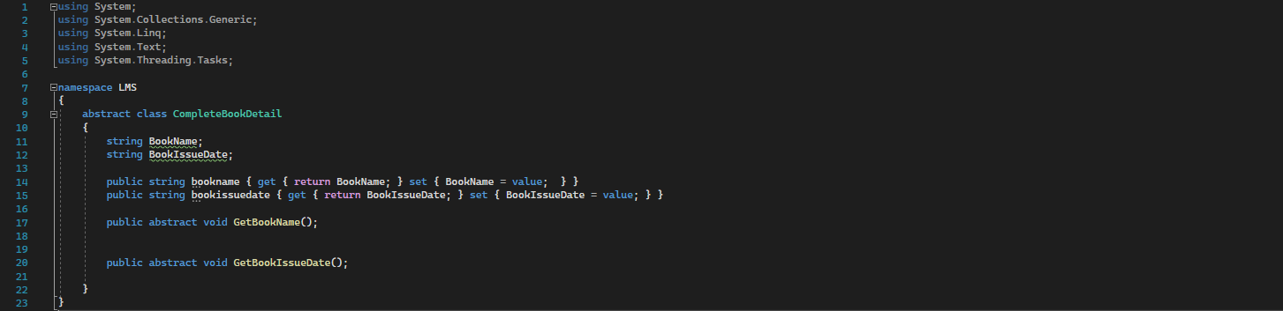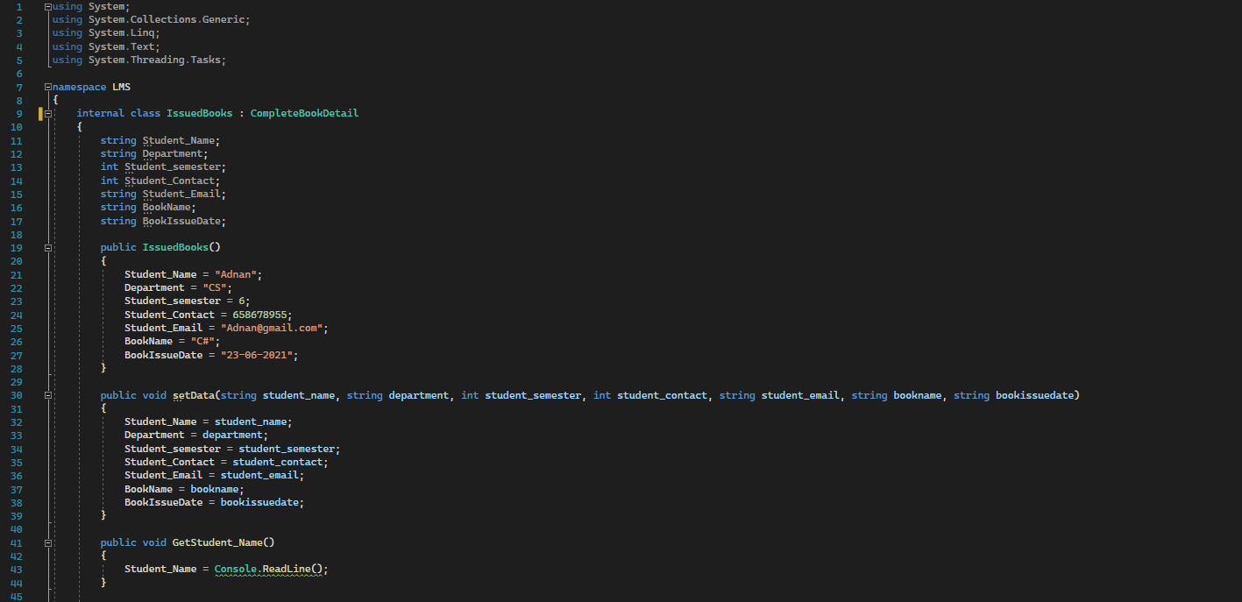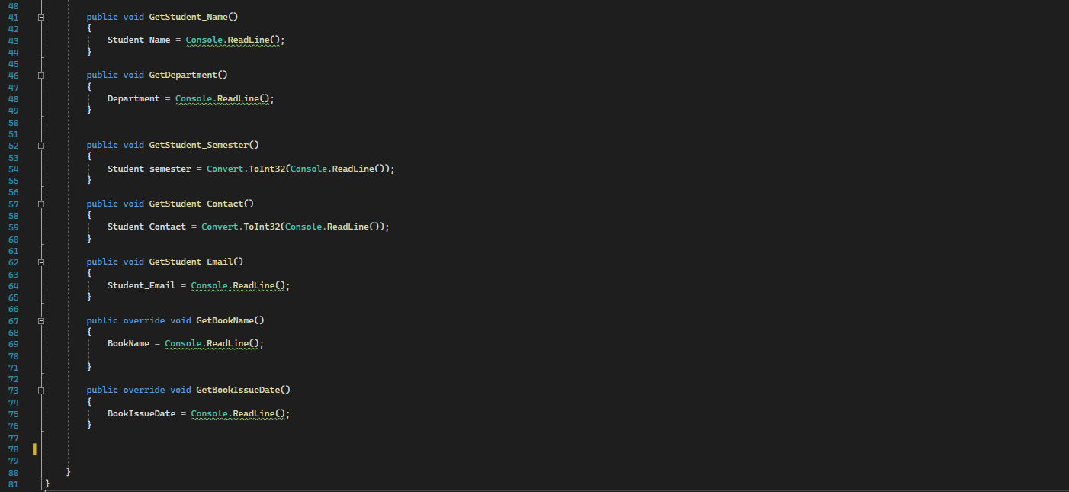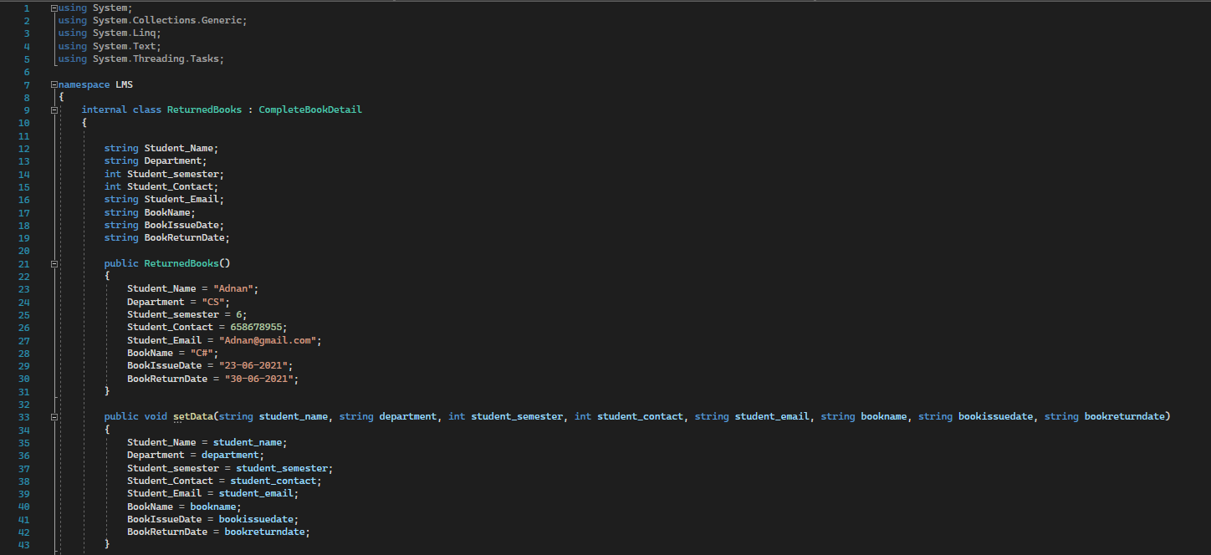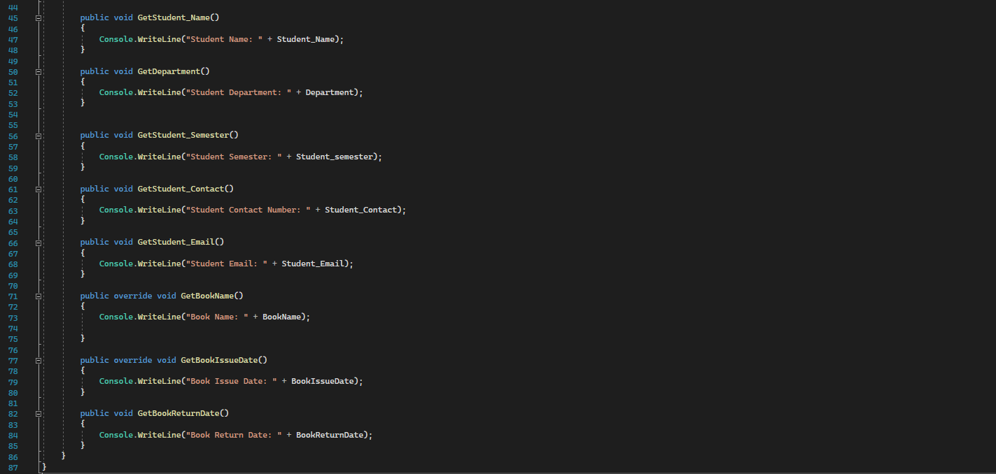

**RESULTS:**

